EDRC Use Case 1, Test Case 1, Section 7.2.10 Process Variations
Revision of EDRC doc:

11 | Updated to reflect comments from David Price | K Willshaw  30 March 2015

Test case spec release 1.0

Template Name : ClassifiedDescriptionOfIndividual

Role Name | Role Type | Role Value
hasDescribed | dm:PossibleIndividual | EQUIPMENT Identifier
valDescriptor | dm:ExpressString | The Text string holding the information
hasDescriptionType | dm:ClassOfClassOfDescription | PROCESS VARIATIONS DESCRIPTION

Note a new RDL item for PROCESS VARIATIONS DESCRIPTION will need to be added.

Comment : valIdentifier role type is incorrect in this table, the template actually states (tpl:valIdentifier only xsd:string)

Comments – the template URI for use in the exchange file is :
http://data.posccaesar.org/tpl/ClassifiedDescriptionOfIndividual

Comments – New test case RD URI for PROCESS VARIATIONS DESCRIPTION used in test case is :
http://rdl.rdlfacade.org/data#PROCESS_VARIATIONS_DESCRIPTION

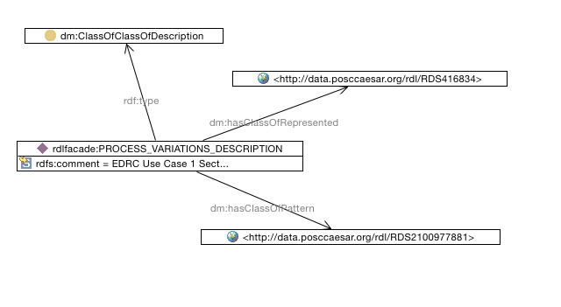
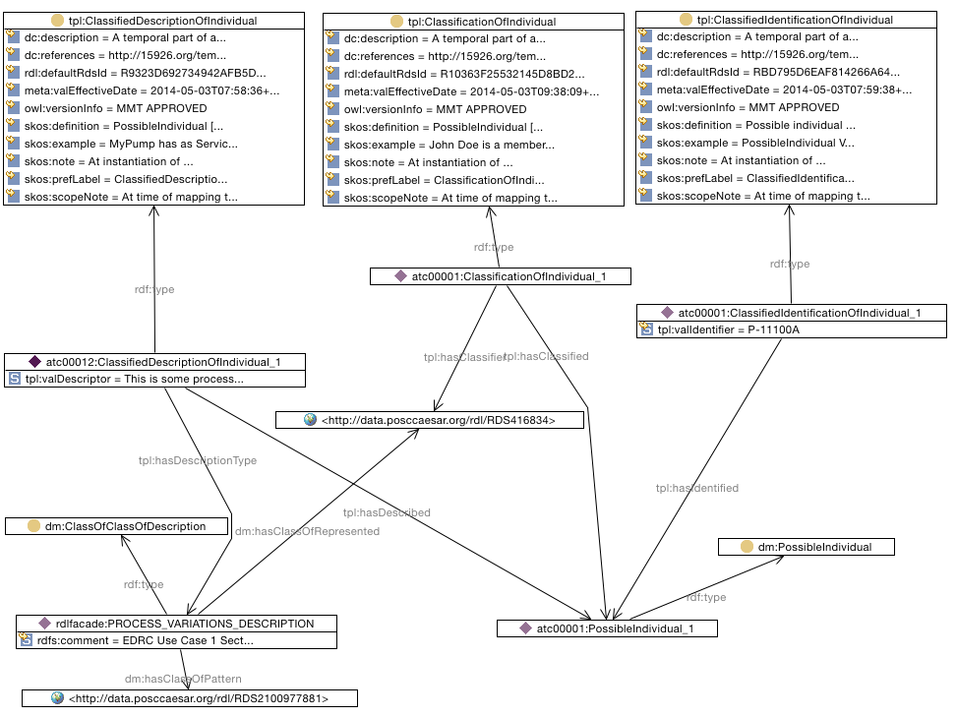

SPARQL to find Process Variations Description of Pump

SELECT ?PumpIdentifier ?PumpProcessVariationDescriptionText
WHERE {
?classificationofindividual tpl:hasClassifier <http://data.posccaesar.org/rdl/RDS416834> .
?classificationofindividual tpl:hasClassified ?possibleindividual .
?classificationofindividual rdf:type tpl:ClassificationOfIndividual .
?possibleindividual rdf:type dm:PossibleIndividual .
?classifiedidentificationofindividual tpl:hasIdentified ?possibleindividual .
?classifiedidentificationofindividual rdf:type ?class .
rdlfacade:PROCESS_VARIATIONS_DESCRIPTION dm:hasClassOfPattern <http://data.posccaesar.org/rdl/RDS2100977881> .
rdlfacade:PROCESS_VARIATIONS_DESCRIPTION dm:hasClassOfRepresented <http://data.posccaesar.org/rdl/RDS416834> .
rdlfacade:PROCESS_VARIATIONS_DESCRIPTION rdf:type dm:ClassOfClassOfDescription .
?classifieddescriptionofindividual rdf:type tpl:ClassifiedDescriptionOfIndividual .
?classifieddescriptionofindividual tpl:hasDescribed ?possibleindividual .
?classifieddescriptionofindividual tpl:hasDescriptionType rdlfacade:PROCESS_VARIATIONS_DESCRIPTION .
?classifiedidentificationofindividual tpl:valIdentifier ?PumpIdentifier .
?classifieddescriptionofindividual tpl:valDescriptor ?PumpProcessVariationDescriptionText
}

Questions

For the new RD item, what are the correct class of pattern and class of represented?
For now these have been set to be DESCRIPTION STRING CLASS and CENTRIFUGAL PUMP.

